Setting up Samba file share server in Ubuntu Server LTS 24.04

Change directory to the directory you want and create your share folder

Retrieve list of available package and then upgrade all installed packages to latest

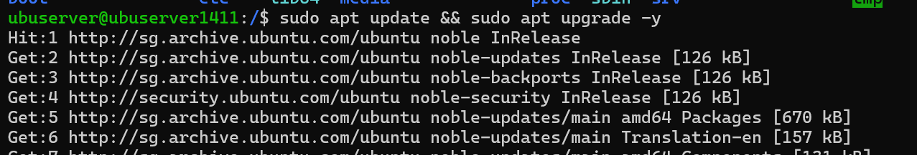

Now install samba

Change your created directory intended for sharing to 777 to let everyone edit

However, use 755 for parent folder /ubuserver using sudo chmod 755 /ubuserver so that while yourself have full rights you only grant read and execute. Can also create a private folder.

Back up original samba config incase of rollback

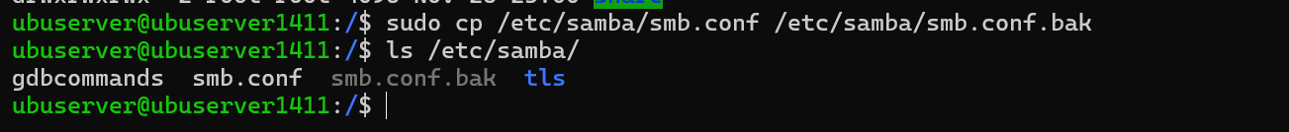

Run a sudo vim/nano and edit the smb.conf and add in the config

Create Samba group

Set user owner of file/directories to root and group owner to be smbgroup. So now, root have the rights to assign group-level access to users in smbgroup.

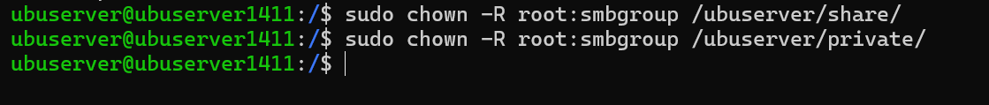

Configure firewall

Before configuring firewall, ensure ssh is still set to allow

Then enable



Add in samba to be allowed and run ufw status again to verify

Then, create a service account that will be used for accessing the shared folder using useradd -M and add -s /sbin/nologin to make it non-interactive (so it cannot be used to ssh in to system)



Add it to the smbgroup since smbgroup users have access to the folder

-aG will add the service account to smbgroup group while retaining current group memberships.

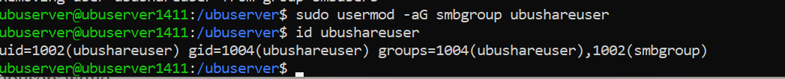

Set password for the created service account, this is different from using sudo passwd

| **Command** | **Purpose** | **Password Context** |
| --- | --- | --- |
| sudo passwd username | Set or update the **Linux system password**. | Used for OS logins (e.g., SSH). |
| sudo smbpasswd -a username | Add/set the **Samba password**. | Used for accessing Samba shares. |

Enable the samba user

Check which account can be used for the samba share access

Also add it to the smbgroup which have access to the samba share folder



For this particular error:

*Unknown parameter encountered: "write cache size"*

*Ignoring unknown parameter "write cache size"*

*lpcfg_do_global_parameter: WARNING: The "encrypt passwords" option is deprecated*

Can remove the 2 config:

write cache size = 262144 # Old way to control write buffering

encrypt passwords = yes # No longer needed as password encryption is now default

Audit configuration

Install Audit daemon

Configure audit rules

sudo auditctl -w /ubuserver -p warx -k samba_share_access



-w /ubuserver: Watch this directory path

-p warx: Monitor these types of access:

* w = write access
* a = attribute changes
* r = read access
* x = execute access

-k samba_share_access: Key name for identifying these events in logs

However, if you want to view audit logs you will have to use ausearch

*# View all events with our key* **sudo ausearch -k samba_share_access**

*# View real-time events* **sudo ausearch -k samba_share_access -ts recent**

Add to smb.conf

[global]

log level = 1 auth:3 winbind:3

vfs objects = full_audit

full_audit:prefix = %u|%I|%m|%S

full_audit:success = mkdir rename unlink rmdir pwrite

full_audit:failure = none

full_audit:facility = local5

full_audit:priority = notice

Start and enable smbd and nmbd services

Smbd: file and print services to SMB clients

Nmbd: NETBIOS nameservice and browsing support

Check status of services

If you want to test connection to the share folder first from your smbgroup service account: can use smbclient //localhost/share -U ubushareuser

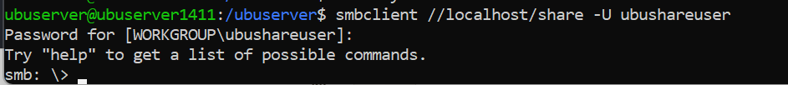

Now you can try to access the network share from your windows client pc

Type in the credentials for the service account created (ubushareuser)

Now if you create a file in your ubuntu server

